|  |
| --- |
| EBIXExCHANGE |
| Group Administration |
| System Access and Reporting |
|  |
| **Shay McBride** |
| **5/10/2013** |

|  |
| --- |
|  |

**Overview**

The purpose of this document is to provide the role of the System Administrator or ‘Group Admin’ as it is referred to for VitalSales Suite, what the Group Admin will have the ability to access and how these changes will impact the end-user and the overall workflow of the VitalSales Suite system.

***Who is the Group Admin?***

The Group Admin is determined by the client and not be Ebix or the VitalSales Suite team. The Group Admin serves as primary contact for any change that occurs in the VitalSales Suite system. Depending on the type of Group Admin, many changes to user access, carrier and products and group settings can be changed by the Group Admin. If the Group Admin is unable to make the requested change in the system, the Group Admin will then reach out to the subject matter expert with VitalSales Suite. The VitalSales Suite team recommends having a primary and backup Group Admin.

***Types of Group Admin***

**Group Administrator**

A Group Administrator (non-Master Group Administrator) has the ability to add and remove Carriers and Products for the assigned VitalSales Suite tools and edit group settings such as colors and logos. This information will be discussed in more detail in the next section of the document.

**Master Group Administrator**

In addition the above mentioned access for a Group Admin, a Master Group Administrator will also have the ability to edit user information such as name, address, phone number and email address. This access will also allow for a user to be enabled or disabled. A Master Group Admin can also add or remove VitalSales Suite tools to a user. For example, if a group has purchased and has access to VitalSigns and VitalAnnuity, the Master Group Admin has the ability to add or remove one of these tools.

**VitalSales Suite Group Settings**

VitalSales Suite allows for a number of user interface changes to be edited, previewed and posted by the Group Admin. Below is a list of settings and what they will modify in the user interface:

**Group Contact Information:** Contact information of the Name, Address, Phone and Email Address of the Primary Contact with the client. In rare cases this is the Group Admin.

**User Interface Settings**

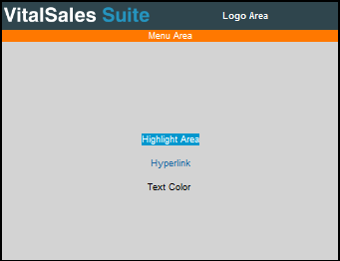

**Page Title:** Page or tab in browser will be referenced with this title.

**Banner:** Appears at the top of VitalSales Suite page above the Menu Area.

**Show Logo Area:** This area displays along the entire area in the top of the page above the menu bar.

**Logo Image Source:** The Logo Area listed above shows the logo for VitalSales Suite. The logo is loaded from the Group Admins machine.

**Logo Image ALT Text:** This is the text that will be viewed when doing a mouse over on the logo.

**Logo Image URL:** This is the URL a user will go to if they click on the logo.

**Logo Area Background Color:** This is the area in the background area of where the logo is located. In the image located above, the color is listed as a dark grey-blue.

**Logo Area Text Color:** This is the color of the text that will appear in the logo area.

**Logout Button Text:** The logout button can have wording other than logout such as ‘Go To…’ That verbiage is placed in this field.

**Logout Button URL:** The URL you would like the Logout button to point to is listed in this area.

**Menu Area Background Color:** This is the background color of the menu area. In the image listed in the Show Logo Area this color is orange.

**Menu Area Text Color:** This is the color the text will appear in the menu.

**Text Color:** This is the color of main text within VitalSales Suite.

**Highlight Area Background Color:** Color of highlight background area.

**Highlight Area Text Color:** Color of highlight text.

**Hyperlink Color:** Color of hyperlinks.

**Underline Hyperlink:** Yes/No

**Users can share cases with other Users**: Options within this setting are as follows:

a) In the same group

b) In the same group and Internal Admin group *(users can share a case within their group and only with Group Admin)*

c) All associated

**Enable EasyQuote Tools:** Check box to enable EasyQuote capability within VitalSales Suite.

**Force Company Name:** Forces User to accept company name as it is within group setup. With this setting the company name cannot be edited by the user.

**Show What's New:** Applies system wide setting. Options within this setting are as follows:

a) Always show What’s New

b) Never show What’s New

c) User Configurable What’s New

**Show PDFs in new window**: Options are as follows:

1. User Selectable
2. Yes
3. No

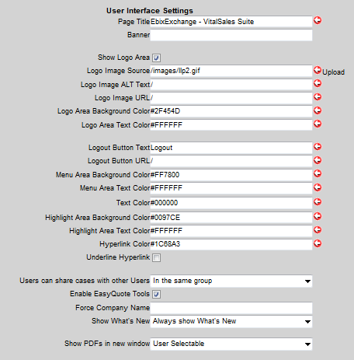

***VitalQuote Settings***

**Report Header Text:** Appears in Header of VitalQuote reports

**Report Footer Text:** Appears in Footer of VitalQuote reports

**Report Disclaimer:** Appears as disclaimer at the bottom of reports

**Force Disclaimer on Printing:** forces when report is printed

**Quick View Report:** Quick View report options

**Show Company Logo on Reports:** shows logo from group settings on reports

**VitalSigns Report Options:**

**Use Class Determinator:** Yes/No

**User Class Determinator Instead of Class Selection:** Yes/No

**Class Determinator Questions:**

* Tobacco Usage
* Cholesterol Level
* Medical History
* Alcohol/Substance Abuse
* Residency
* Hazardous Sports/Avocation/Aviation
* Blood Pressure
* Family History
* Driving Record
* Foreign Travel
* Criminal Activities

**Show Age Nearest/Last Input selections:** Yes/No

**Minimum Face Amount to Quote:** Select Amount

**Locked VSS Classes:** Select Class

**Large Quote Notification:** When large class is quoted an email will be sent to identified recipient.

* Face Value:
* Premium:
* Contact email (required):

**Show solve for face amount option:** Yes/No

**Show AM Best Ratings for LLXML:** Yes/No

**Use Flat Extras:** Yes/No

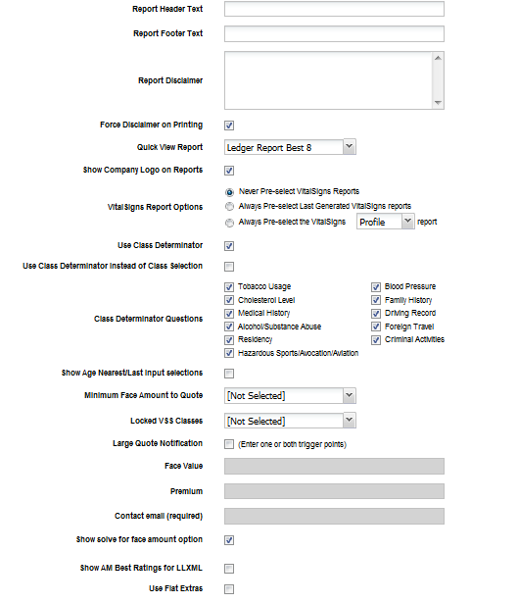

**VitalAnnuity Settings**

**Show Client Interview Interface:** Yes/No

**Show Annuity Selector:** Yes/No

**Editing User Information and Access**

The following user information can be edited by a Group Admin:

* **User Name:** by editing the username the case history for that user will not be accessible to that user. It is not recommended to change the username for this reason and is trained as such.
* **First Name**
* **Middle Initial**
* **Last Name**
* **Company Name**
* **Credentials**
* **Address**
* **City**
* **State**
* **Zip**
* **Phone**
* **Fax**
* **Email**
* **Agent Number**

A Group Admin has the ability to create and disable but does not have the ability to delete a user from the system. Included in modifying a user’s access, a Group Admin can disable all access to VitalSales Suite or can add/remove a VitalSales Suite tool (i.e. VitalQuote, VitalSigns)

**Adding and Removing Carriers and Products**

Adding and removing carriers and products is the responsibility of the Group Admin. If a new carrier or product has been added to a tool VitalSales Suite and the client is using a sub set of products or a product list (not all of the products), it will not be automatically added to the list of products used by a particular client.

Carriers and products are maintained separately based on the VitalSales Suite tool and managed in or will be eventually be managed in the Product List System or PLS.

***Product List System***

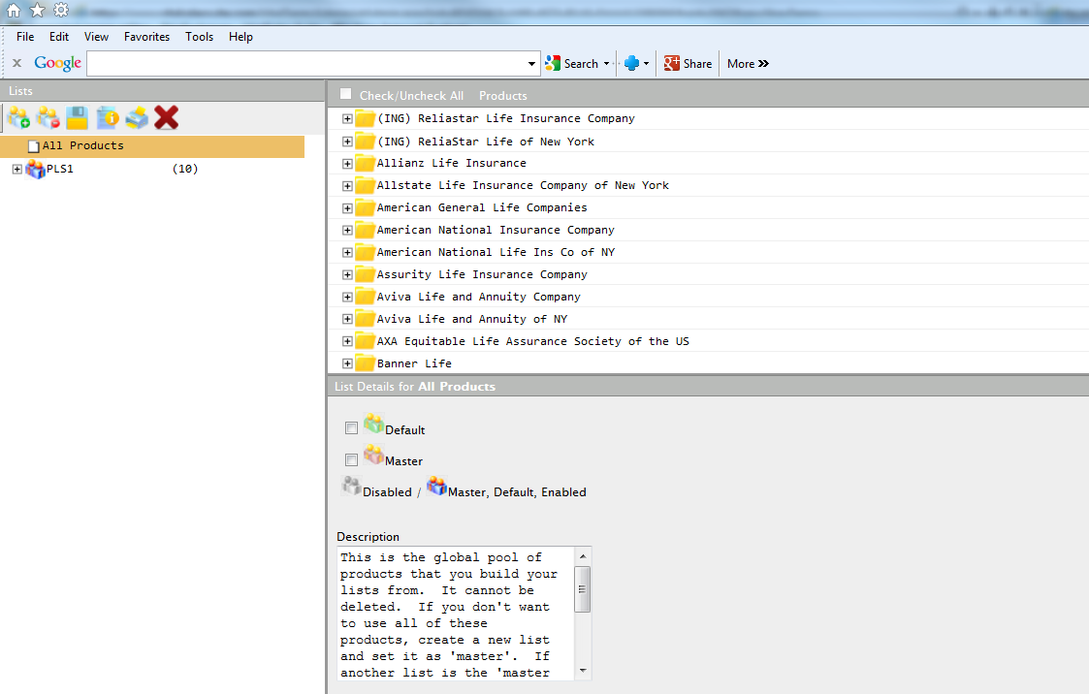

The icons in the upper left hand corner have the following meanings:

 - Create a new list

 - Delete an existing list

 - Save changes

 - Instructions

 - Print product list

 - Close window (this will prompt you to save your changes)

**Creating a new List:**

To create a new list, use the icon referenced above. Name the list. Remember the name of this list will be viewable those that have access to your system. Follow the instructions below to add products to your list.

**Adding products to Lists:**  
To add a product/carrier to a list, make sure you have the proper list selected on the left. Simply check the items you wish to include. If you check a carrier, all of the products of that carrier will be added for your list. If you check a product, only that product will be added. The same rules apply for removing (un-checking) the product/carrier. If you need to check/uncheck all products for a list, you can use the "Check/Uncheck All" checkbox at the top, above the list of products.  
  
**List Details:**

**Master List:**  
All groups start out with an All Products list. This list is un-editable. If you wish to not have All Products for users to choose for their tools, simply create another list with all the products you wish to use and select that list as the "Master" list. This will in turn remove the All Products list from the user's tools.

**Enabled:**

A list can be created and be enabled or disabled at any time. If a list is in the process of being created by may not take effect until a later date simply uncheck the enabled check box.

**Default:**

If the All Products list of multiple lists are created a Default list needs to be identified. The Default list will be the list that appears in the default position of the drop down menu of the product list field in VitalQuote. Unless the product list is changed to another list, the user’s quote will run against the products listed in the default product list.

**VitalSales Suite Reports**

**VSS Numbers Report -** *Number of reports run by group for each tool during a specified period of time.*

Parameters of report include:

* Start Date
* End Date
* Report type = PDF or Excel

**User Usage Report** – *Number of reports run by user for each tool during a specified period of time.*

Parameters of report include:

* Start Date
* End Date
* Order By = User Name, First Name, Last Name, Logins, VSS Quote/Report
* Find User =All Users, User Name, Last Name
* Report type = PDF or Excel

**User Information Report** – *Current and Expired user's registration information.*

Parameters of report include:

* Criteria = All Records, Create Date, Last Login
* Start Date
* End Date
* Order By = User Name, First Name, Last Name, Create Date
* Report Type – PDF or Excel

**Product Usage Report** - *Statistics about VSS products run.*

Parameters of report include:

* Criteria =, <, >, (Specify value)
* Start Date
* End Date
* Order By = Depends of VSS Product
* Report Type – PDF or Excel